REVA UNIVERSITY

 SCHOOL OF COMPUTER SCIENCE AND ENGINEERING

WEB TECHNOLOGY PROJECT

BY- S B KEERTHAN -R20EF254

MANOJ R -R20EF241

PRANAV R-R20EF248

LOHITH K -R20EF239

5TH SEM 'E' SECTION

**STUDENT SURVEY FORM**

**Project Title**: Student Survey Form Using HTML, CSS, JAVA SCRIPT, PHP.

**INTRODUCTION**

Surveys are regularly used to make individual decisions—like whether to run a particular advertising campaign or create a new service—but they get even powerful when repeated over time.

Many people use surveys for work or for school, but they can be just as helpful in day-to-day life. Surveys are designed to give you useful information and bring clarity to difficult decision-making processes—and personal life can be just as tangled and confusing as anything that happens in an office.

A survey form consists of input fields and options that enable users to input their unbiased opinion regarding the survey topic, which the survey provider subsequently analyses.

Basically, survey forms will help you improve your products and related services as you'll be able to make a formal decision based on the feedback received.

**OBJECTIVES**

The main objective of the entire activity is to create a website for student survey form.

* To acquire the required information from students.
* Analysing the collected data.

**METHODOLOGY**

**HTML:** Hypertext Markup Language (HTML) is the standard markup language for creating web pages and web applications. With Cascading Style Sheets (CSS) and JavaScript, it forms a triad of cornerstone technologies for the World Wide Web. Web browsers receive HTML documents from a web server or from local storage and render the documents into multimedia web pages. HTML describes the structure of a web page semantically and originally included cues for the appearance of the document.

#### CSS: Cascading Style Sheets (CSS) is a style sheet language used for describing the presentation of a document written in a markup language like HTML.CSS is a cornerstone technology of the World Wide Web, alongside HTML . CSS is designed to enable the separation of presentation and content, including layout, colours, and fonts. This separation can improve content accessibility, provide more flexibility and control in the specification of presentation characteristics, enable multiple web pages to share formatting by specifying the relevant CSS in a separate CSS file, and reduce complexity and repetition in the structural content.

**PHP:** PHP is an open-source, cross-platform, object-based scripting language for dynamic Web applications that is analogous to ASP. Versions of PHP run on many operating systems and Web servers, and interfaces are available to many database systems. PHP is available for Windows operating systems, but since ASP being generally the preferred option on Windows systems, PHP is most prevalent on Linux systems running Apache. The PHP syntax contains elements borrowed from C, Perl, and Java. Figure 14 shows an example PHP script. While PHP has comparable advantages and disadvantages as classic ASP, the portability of PHP can be beneficial if an application needs to run on several platforms or Web servers.

#### JS: JavaScript (often shortened to JS) is a lightweight, interpreted, object-oriented language with first-class functions, and is best known as the scripting language for Web pages. It is a prototype-based, multi-paradigm scripting language that is dynamic, and supports object-oriented, imperative, and functional programming styles.

**MYSQL:** MySQL is an open-source relational database management system (RDBMS).Its name is a combination of "My", the name of co-founder Michael Widnes’s daughter and "SQL", the abbreviation for Structured Query Language. A relational database organizes data into one or more data tables in which data may be related to each other; these relations help structure the data. SQL is a language programmers use to create, modify and extract data from the relational database, as well as control user access to the database. In addition to relational databases and SQL, an RDBMS like MySQL works with an operating system to implement a relational database in a computer's storage system, manages users, allows for network access, and facilitates testing database integrity and creation of backups.

#### ABSTRACT

This Project is developed using HTML, & CSS.

Survey research is a unique methodology that can provide insight into individuals' perspectives and experiences and can be collected on a large population-based sample. Specifically, in plastic surgery, survey research can provide patients and providers with accurate and reproducible information to assist with medical decision-making. When using survey methods in research, researchers should develop a conceptual model that explains the relationships of the independent and dependent variables. The items of the survey are of primary importance. Collected data are only useful if they accurately measure the concepts of interest. In addition, administration of the survey must follow basic principles to ensure an adequate response rate and representation of the intended target sample. In this article, the authors review some general concepts important for successful survey research and discuss the many advantages this methodology has for obtaining limitless amounts of valuable information.

**SCREENSHOTS OF OUTPUT:**

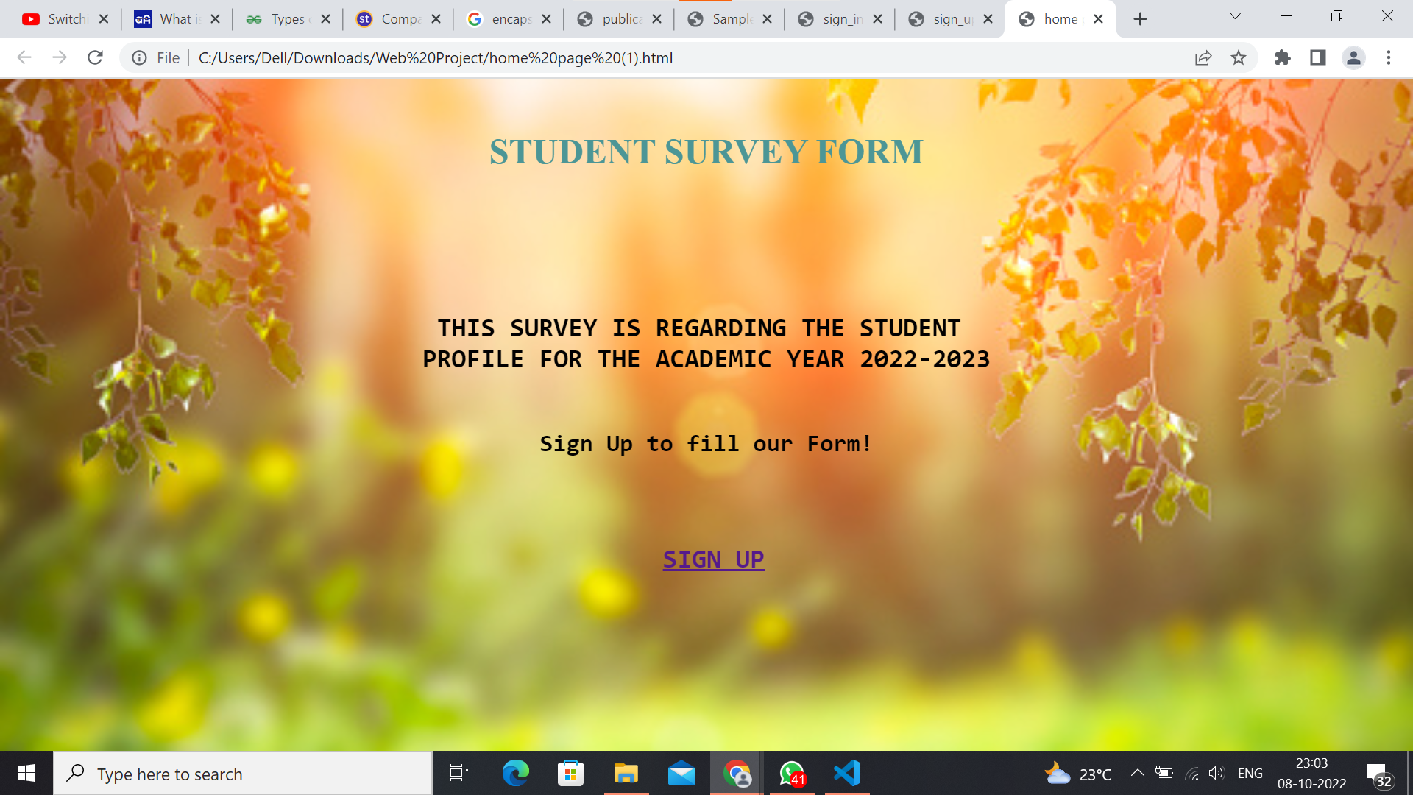

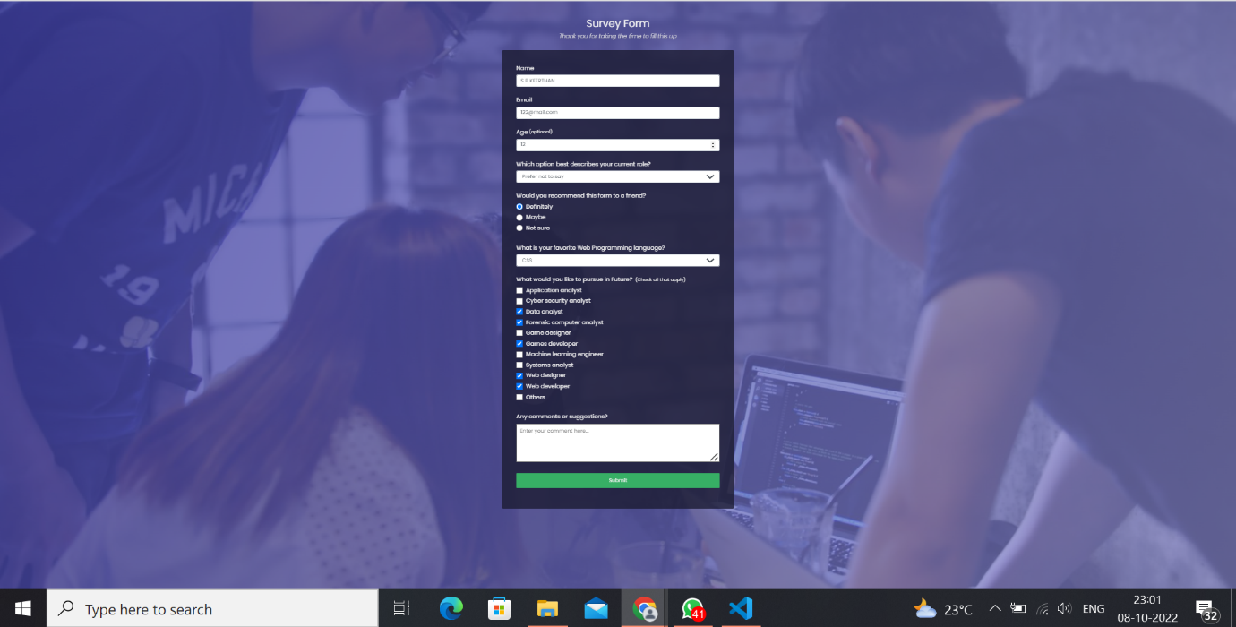

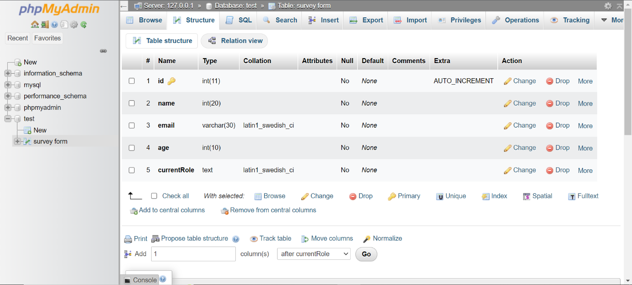

**CONCLUSION**

Using HTML, CSS , JAVA SCRIPT and PHP we have created an interactive Student Survey Form, using which Institutions can collect data of the students.